CSC258 Prelab

Part1

1. It is an active low synchronous reset. If reset is low, and after the key be released, the state should become to A.
2. 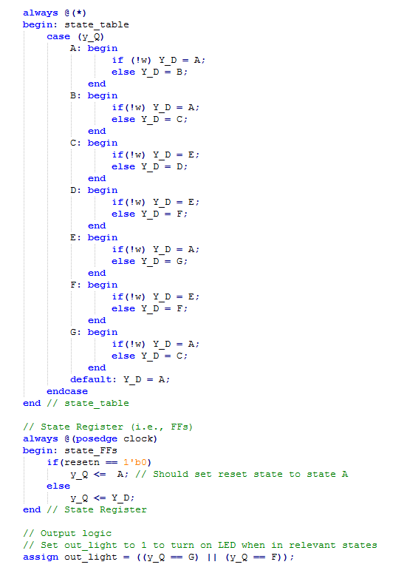

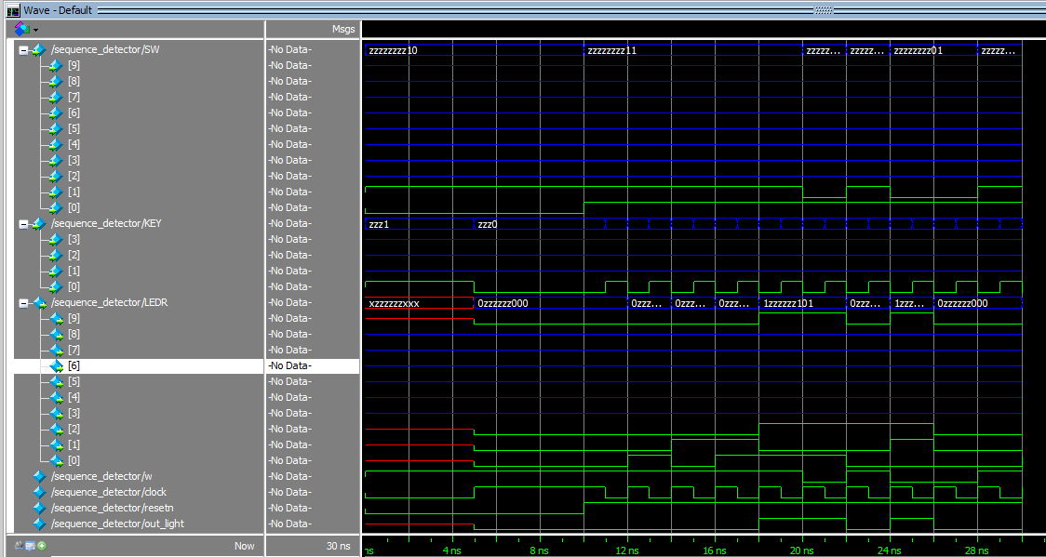

Part2:

|  |  |  |  |  |  |
| --- | --- | --- | --- | --- | --- |
| High-level Step | Control Signals | Register A | Register B | Register C | Register X |
| Load data into A | ld_a = 1 | A | 0 | 0 | 0 |
| Load data into B | ld_b = 1 | A | B | 0 | 0 |
| Load data into C | ld_c = 1 | A | B | C | 0 |
| Load data into X | ld_x = 1 | A | B | C | X |
| multiply A & X, store | ld_alu_out = 1'b1; ld_a = 1'b1; | A * X | B | C | X |
| result in A | alu_select_a = 2'b11; alu_select_b = 2'b00; |  |  |  |  |
|  | alu_op = 1'b1; |  |  |  |  |
| multiply A & X, store | ld_alu_out = 1'b1; ld_a = 1'b1; | A * X * X | B | C | X |
| result in A | alu_select_a = 2'b11; alu_select_b = 2'b00; |  |  |  |  |
|  | alu_op = 1'b1; |  |  |  |  |
| multiply B & X, store | ld_alu_out = 1'b1; ld_b = 1'b1; | A*X*X | B*X | C | X |
| result in B | alu_select_a = 2'b01; alu_select_b = 2'b11; |  |  |  |  |
|  | alu_op = 1'b1; |  |  |  |  |
| add B to A, store | ld_alu_out = 1'b1; ld_a = 1'b1; | A*X*X+B*X | B*X | C | X |
| result in A | alu_select_a = 2'b00; alu_select_b = 2'b01; |  |  |  |  |
|  | alu_op = 1'b0; |  |  |  |  |
| add C to A, store | ld_r = 1'b1; alu_select_a = 2'b00; | A*X*X+B*X+C | B*X | C | X |
| result in result register | alu_select_b = 2'b10; alu_op = 1'b0; |  |  |  |  |

2.

4.

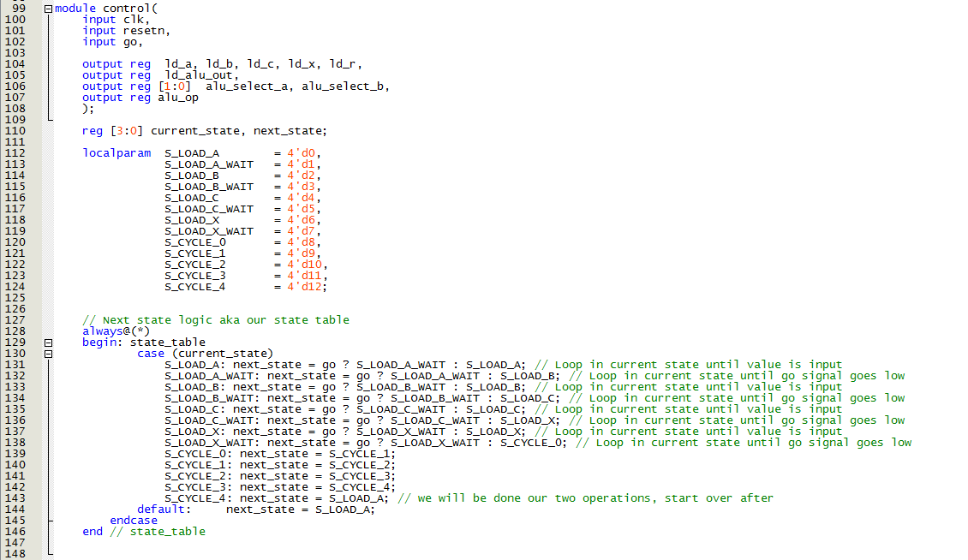

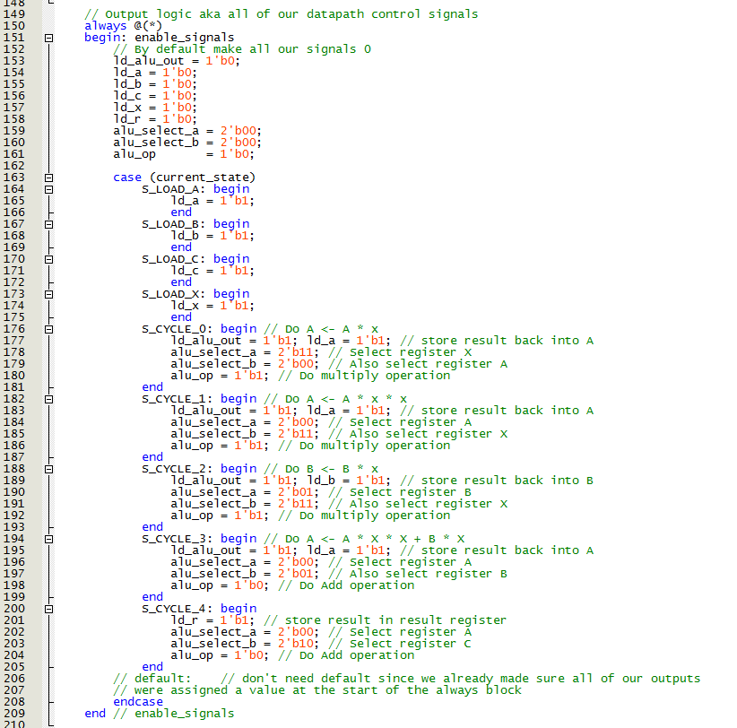

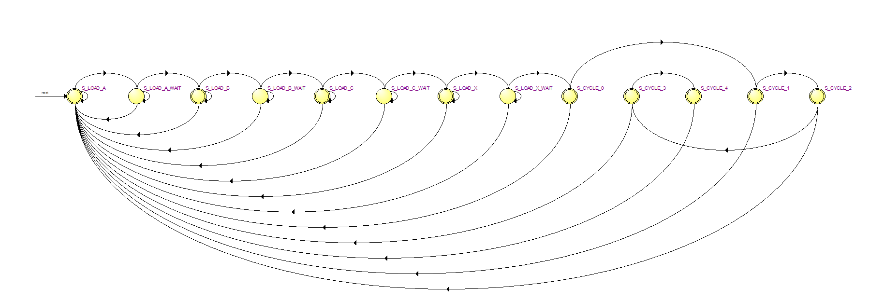

1. Simulation for controller

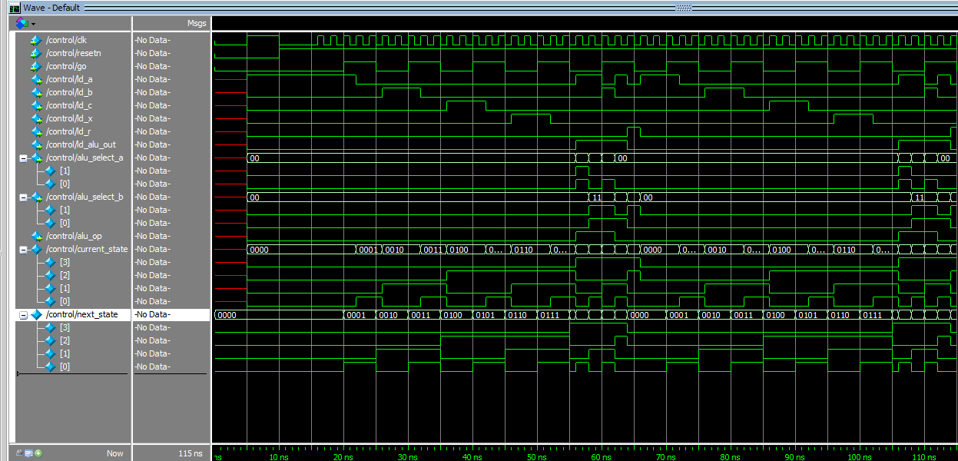

Simulation for datapath

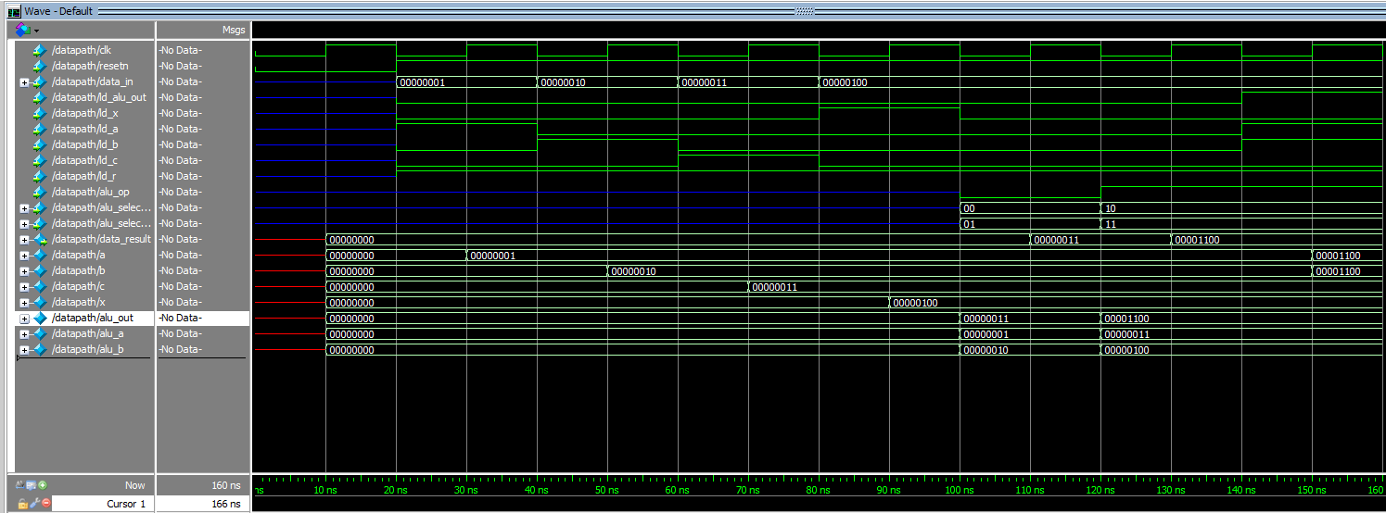

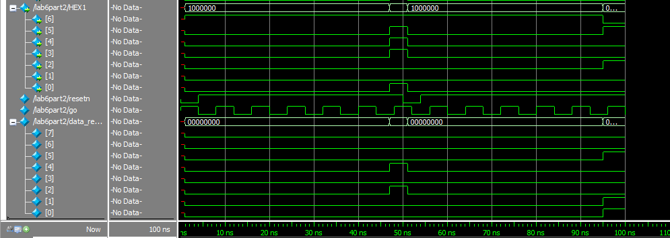Simulation for whole program

